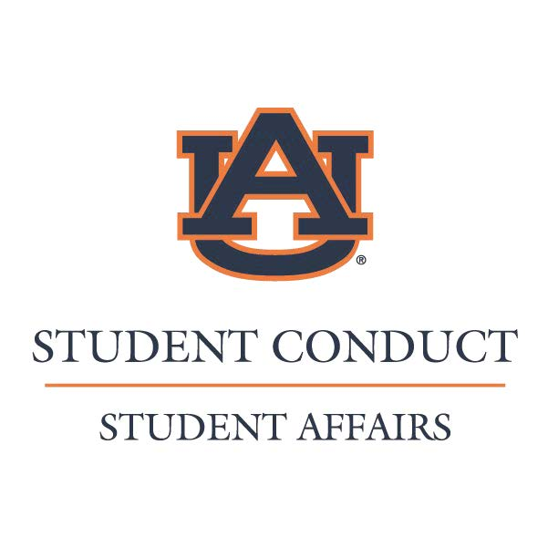
_________________________________________________________________________
Witness Statement Submission Form
By completing and signing this witness statement I hereby affirm that the following written account is honest and true to the best of my recollection.

Statement

__________________________________________ _____________________________________________
Name (Please print) Signature

__________________________________________ ___________________________________________
Email Address Date

Student Conduct | Student Center Suite 1115 | Auburn, AL 36849-5596 | (334) 844-1305 (Phone) | (334) 844-1132(Fax)

